This document will go over how the firework spawner was implemented and will assume that we don't need to explain the basis of the engine itself since we just copied the code from class.

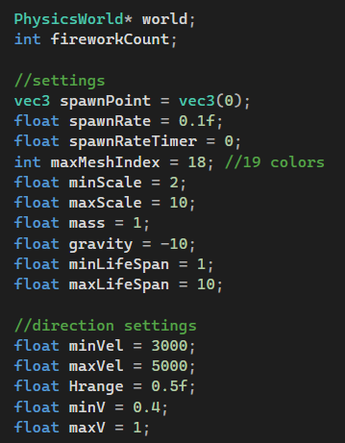
These are the private vars.

The physics world pointer is passed in the constructor to have access to the class and directly assign created particles to the world. Same with the fireworkCount, the program asks how many fireworks can exist at once before starting the program.

Next are the settings, most of them are used in the create firework function for the random parameters.
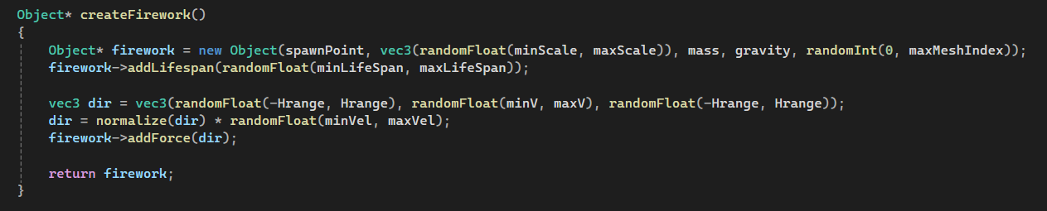
For the implementation of our engine, we named particles as objects and were too lazy to change it. This version of the engine doesnt have the force generators implemented yet so gravity is directly passed into the object constructor.

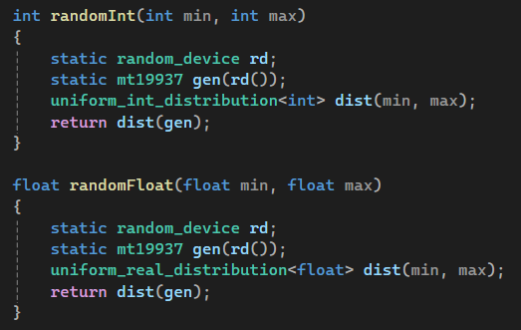
We also implemented a random int and float function to make the create firework function shorter.

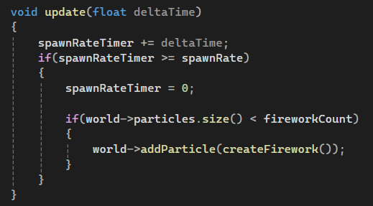
Last is the update function, this is directly placed in the physics loop in the main.cpp loop.

